WELCOME TO OUR TEAM
LDHV
PAC K-612

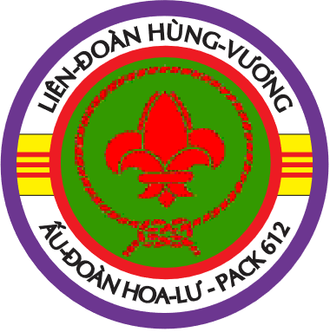
Aug 2019

Greeting: Pack Leadership and Cub scouts welcome you all to join our team. We hope you will find it is the right place for you with lots of friends while seeking a good team to start your scouting journey.
Introduction of Pack 612: Pack-612 has been around for more than 15 years, our current 3rd generation Cub Master is Tr. Nghia. We presently have 30 Cubs and 10
Den leaders who handle the Pack weekly operation.
Contact Information:
- Cub Master: Tr. Nghia; Phone: 571-314-2182; email: hoanghuunghia@gmail.com
- LDVH website:
http://www.ldhv612.com/
- Pack-612 Handbook: https://docs.google.com/document/d/1FmsVBXrAWVTRX7CD4p1D8kbu89GW_dI79bhm2r8tzDw
For more information needed, please visit LDHV website and Pack-612 Handbook listed above.
Communication:
- Communication within Pack leadership and parents primarily via LD or Pack leadership group email, these google group emails are maintained & updated frequently by LD & Pack leadership when the updated information is available.
- New parent’s emails will be added to our google group (ldhv612@googlegroups.com) as soon as your information is available to us.
Meeting schedule & activities
- We meet very Friday from 6:30pm to 8:00pm during school calendar year, and we schedule outdoor camping 3-4 times/year in local BSA sites & Fairfax county parks.
- We observe the FCPS inclement weather announcement, and national holidays. So, please pay close attention on local news and emails from LD or Pack leadership for the upcoming events.
Uniform policy: All youths & Leaders need to wear proper class A uniform during Pack meetings and class B uniform during outdoor activities.
Class A uniforms can be purchased at:
Scout shop: 5234 Port Royal Rd, Springfield, Virginia. Phone: (703) 321-4836; Scout shop online: https://www.scoutshop.org/
Class A uniform consists of: A blue long-or short shirt & pants (skirt is optional for girl), a Council insignia patch, set of Pack # 612, a World Scout Crest patch, a blue Belt, a Neckerchief & a Woggle (neckerchief is provided by Pack, scout will learn & make their own woggles). Uniform hat and Webelos Scout tan shirt, green pants & green belt are currently optional. Class B uniforms can be purchased through LDHV.
Cub Scout ranges based on ages & school grades:
- 10-11-year-old, or in 4th and 5th grade: Webelos
- 9-year-old, or in 3rd grade: Bear
- 8-year-old or in 2nd grade: Wolf
- 7-year-old, or in 1st grade: Tiger
- 6-year-old: Lion
Parent participation requirement:
- Presence of parents are required at all time during Pack meetings and outdoor activities. If parents are not available than the adult substitution should be present, and Pack Leaders should be notified.
- Parents are encouraged to help the Cubs on their Pack assignments at home to maintain their progress of learning curve.

